
ACADEMIC TALK
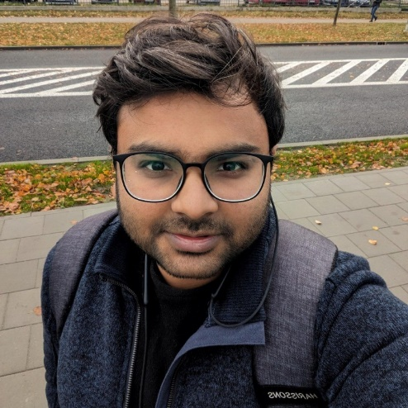
4th Octtober 2024, friday 3.00pm-4:00PM A3-824

Talk Abstract
Affiliation: ICTQT University of Gdańsk

Title: A bosonic open system approach to superconducting nanodevices

Abstract:
Josephson junctions are the heart of superconducting devices that underpin emerging quantum technologies. Despite significant attention, a theoretically consistent description of Cooper pair dynamics is still an open question. We build a robust theoretical framework for studying the dynamics of arbitrary nanodevices and utilize it to propose a dissipationless geometry for pumping a supercurrent. Cooper pairs in the terminals of Josephson junctions are treated as bosonic open quantum systems governed by a Markovian master equation. Although phenomenological at large, our model opens up new avenues to envision novel superconducting platforms for probing the theory of open quantum systems.

About the speaker
AK finished his PhD studies at the Indian Institute of Technology Roorkee in India with a strong collaboration at the University of Gdansk in Poland. He is currently a postdoctoral researcher in the New Quantum Resources and Thermodynamics group at the International Centre for Theory of Quantum Technologies in Gdansk. His current research is focused on spin chain dynamics and a bosonic open system model for superconducting nanodevices.
A bosonic open system approach
to superconducting nanodevices
Tomasz.paterek@xmu.edu.my │ Department of Physics │ Xiamen University Malaysia

